Online Enrollment System with E-learning Management System for Daehan College of Business and Technology

A Thesis

Presented to the Faculty of

Information and Communications Technology Program

STI College Ortigas Cainta

In Partial Fulfilment

of the Requirements for the Degree

Bachelor of Science in Computer Science

Jeriko Ronnel S. Coz

Dhan Exequiel M. Cultura

Justine Adrian A. Sirios

Rhandyl A. Tapuroc

December 7, 2022

ENDORSEMENT FORM FOR ORAL DEFENSE

TITLE OF RESEARCH: Online Enrollment System with Learning Management System for Daehan College of Business and Technology

NAME OF PROPONENTS: Jerkio Ronnel S. Coz

Dhan Exequiel M. Cultura

Justine Adrian A. Sirios

Rhandyl A. Tapuroc

In Partial Fulfilment of the Requirements

for the degree Bachelor of Science in Computer Science

has been examined and is recommended for Oral Defense.

ENDORSED BY:

Gerven Jay Regado

Thesis Adviser

APPROVED FOR ORAL DEFENSE:

Lexter A. Santos

Thesis Coordinator

NOTED BY:

Salvador T. Gascon

Program Head

April, 2023

# APPROVAL SHEET

This thesis titled: Online Enrollment with Learning Management System for Daehan College of Business and Technology prepared and submitted by Jeriko Ronnel S. Coz; Dhan Exequiel M. Cultura; Justine Adrian A. Sirios; and Rhandyl A. Tapuroc, in partial fulfilment of the requirements for the degree of Bachelor of Science in Computer Science, has been examined and is recommended for acceptance an approval.

Gerven Jay Regado

Thesis Adviser

Accepted and approved by the Thesis Review Panel

in partial fulfilment of the requirements for the degree of

Bachelor of Science in Computer Science

|  |  |
| --- | --- |
| Precious Love Rafael | Ron Allan N. Salem |
| Panel Member | Panel Member |

Lexter A. Santos

Lead Panelist

APPROVED:

|  |  |
| --- | --- |
| Lexter A. Santos | Salvador T. Gascon |
| Thesis Coordinator | Program Head |

April, 2023

# Table of Contents

|  |  |  |
| --- | --- | --- |
|  | | Page |
| Title Page | | i |
| Endorsement Form for Proposal Defense | | ii |
| Approval Sheet | | iii |
| Table of Contents | | iv |
| List of Figures | | v |
| List of Appendices | | vi |
| Introduction | | 1 |
|  | Background of the problem | 4 |
|  | Overview of the current state of technology | 7 |
|  | Objectives of the study | 9 |
|  | Scope and limitations of the study | 11 |
| Literature Review | | 15 |
|  | Review of related literature, studies or systems | 15 |
|  | Synthesis | 19 |
| Online Enrollment System with | | 21 |
| References | | 25 |
| Appendices | | 29 |
|  | |  |
|  | |  |

# List of Figures

|  |  |  |
| --- | --- | --- |
| Figure |  | Page |
| 1 | Iterative Waterfall Model | 21 |
| 2 | DCBT Organizational Chart | 85 |
|  |  |  |
|  |  |  |
|  |  |  |

# List of Appendices

|  |  |  |
| --- | --- | --- |
| Appendix |  | Page |
|  | A. Gantt chart of activities | 30 |
|  | B. Actual Thesis Expenses | 33 |
|  | C. Curriculum Vitae of Researchers | 35 |
|  | D. Project Proposal Letter | 40 |
|  | E. Research Design | 42 |
|  | F. Location of the School | 44 |
|  | G. Company Letter | 47 |
|  | H. Delimitations of the Study | 49 |
|  | I. Population of the Study | 51 |
|  | J. Sample of Population | 53 |
|  | K. Sampling Technique | 55 |
|  | L. Instrument for Data Collection | 57 |
|  | M. Method of Data Collection | 59 |
|  | N. Sample Interview Questions | 61 |
|  | O. Survey Questionnaire | 63 |
|  | P. Transcript | 71 |
|  | Q. Teachers, SHS, and College Student Population | 79 |
|  | R. Organizational Chart | 84 |

# Introduction

Technology is the application of scientific knowledge to the practical aims of human life or as it is sometimes phrased, to the change and manipulation of the human environment. Since the 18th century during the industrial revolution, technology is becoming more popular in most industries as we have found it beneficial for us to be more productive and become more innovative when creating solutions (Britannica, 2022).

Since 1990 it is estimated that half of a percent of the world population were online; but everything has changed since then Globally, the number of Internet users increased from only 413 million in 2000 to over 3.4 billion in 2016 (Our World in Data, 2016).

The education sector has benefited greatly from technological advances. Digital technological advancements have had a significant impact on teaching and learning practices for decades now. The exponential growth in ICT developments has expanded and optimized teaching methods, encouraged the development of various pedagogical ideologies, and widened the educational system (Research.com, Bouchrika, 2022). It allows them to use modern technology to their advantage bringing utmost convenience and efficiency – the discovery of new learning implementations integrates a more engaging learning environment. Since the start of the pandemic, the education industry has been one of the most affected; which results in seeking new ways to connect students and teachers. One of the most common solutions is through the internet. All duties, lessons, assignments, and meetings take place online. At the occurrence of the pandemic in 2020, the Philippines strictly implemented online learning. Technology yet again played a huge role in the Education industry. The adoption of the Learning Management System has become a notable phenomenon in the country's education system, from lower to higher education. Even so, it is said to be really effective; a study made by BMC Medical Education(2022)

One of the ripple effects of the stifling competition for education institutes is the growing necessity for schools to enhance their mechanisms for better serving applicant’s queries and objections. This is where enrollment systems come into play, simplifying and accelerating student enrollment. In simpler words, an enrollment system combines all activities involved in the entire enrollment process and integrates them into a system. This way, everything happens in one place, both online and offline. The conversation happened with the prospects, the pages they are visiting, their interests and motivations, their personal details, the meetings scheduled with them to name a few. The overall objective of an enrollment system is to help admission teams ultimately enroll more students (Joshi, 2022).

A learning Management System or LMS is a software application or web-based technology used to plan, implement and assess a specific learning process. It is used for eLearning procedures and, in its most basic configuration, consists of two components: a server that handles the essential functionality and a user interface that is controlled by teachers, learners, and administrators (TechTarget, Brush, 2019).

As technology has become an essential part of education, the developers conducted this research to develop an Online Enrollment System with Learning Management System dedicated to a private educational institution in the Philippines, Daehan College of Business and Technology (DCBT) is located at Rd.20 Siwang San-Juan, Taytay Rizal. DCBT was established in 2015 as an educational institution that offers senior high school and college courses, and is known for its classes in ministry and Korean classes; as of today, they are conducting blended learning which is a mix of online and face-to-face classes. The goal is to develop an Online Enrollment with Learning Management System that will pave the way for a centralized platform that addresses the lacking factors from their existing system.

## Background of the problem

## General Problem

* Daehan College of Business and Technology manually enroll students and using multiple third-party applications as an alternative to establish their learning environment

Daehan College of Business and Technology (DCBT) is currently relying on a manual process of enrollment. Enrolling students manually with only one registrar will prolong the enrollment process, prone to errors and take too much time to complete. The registrar takes too much time to handle all the students, resulting in a longer enrollment process. DCBT is currently using different type of application which is Google Drive, Google classroom and Messenger to meet students activity and school related works, given the fact that using this existing application is beneficial however relying upon this kind of setup can cause working unorganized way of sending data from the student because they need to open different window of an application to submit the activity on time. That’s why DCBT aims to have a centralized system that can accommodate teacher and student activities and minimize the use of different applications just to complete activities, submit and view grades in every period.

## Specific Problem

* Daehan College of Business and Technology’s teachers are not adequately monitoring the academic progress and performance of their students.

The current system of the client cannot efficiently track the student's progress in an asynchronous session. Based on the interview, teachers of Daehan College of Business and Technology are still using traditional ways of tracking students' progress in asynchronous sessions going students' output that is submitted online.

The teacher has said that it would be beneficial if they can keep track of the student's progress from time to time, which includes if the student opened their respective modules given by the teachers. Another important aspect of tracking progress is having a constant overview of overall progress such as showing overall grades in every period on their ELMS and showing scores of each checked task/activity which currently can only be viewed at the end of the period.

* Registrar manually inputting student’s record

The registrar manually inputting enrollment information into an Excel sheet can also cause delays in the scheduling process. This is due to the time-consuming nature of manual data entry, which can result in longer processing times and delays in scheduling. In addition, the possibility of duplicate data entry is a concern as it can cause inconsistencies and errors in the final schedule. Duplicate data entry occurs when the same student information is entered multiple times by mistake.

* The students are required to enroll manually on every end of semester

Students of Daehan College of Business and Technology (DCBT) are required to enroll manually and fill out form every end of semester, even if they are regular or enrolled in previous enrollment, this results in time-consuming for both registrar and students, also with this manual process the school experiences data loss.

## Overview of the current state of the technology

Daehan College of Business and Technology (DCBT) has their own implementation for organizing their school-related work to complete their day-to-day work. Some of them have been using a modernized approach where they used technologies as their primary tool to have another level of conveniently organizing their school-related work to make it more efficient and faster than the manual process. Daehan College of Business and Technology currently using Google Classroom, Google Drive and Messenger as an alternative tool to organize their school-related works which serve as their learning environment to fill in the gaps of their needs in online learning where school teachers are willing to share their knowledge with students who are hardworking and willing to learn. The platform's functions that they have commonly used to organize their school-related works include student task dissemination that is automatically populated into the students’ calendar, and accessing/grading student assignments where they are dependent on the platform not having an opportunity to modify the behavior according to their wants. Considering the hardship and challenges of online class learning, this ensures they`re tracking students' performance progress and allows students to prioritize their school workload to ensure that the learning is effectively absorbed.

DCBT currently uses alternatives applications that serve as their primary tool to such as Google Classroom where Teacher allows to disseminate students' tasks, access student`s submissions and mark student assignments on the other hand, it grants the students to view their respective tasks, submit their requirements for activities and homework, accessing their module and planning their homework and assignment as they can see all of their tasks for the week. Messenger on the other hand is also used by some teachers to disseminate learning modules and means of communication regarding the subject matter where the teacher created a group chat for his/her teaching subject and all the sections that have the same subject were included in the group. Lastly, Google Drive where students can submit their works and activities.

The proposed Learning Management System for DCBT aims to centralize a systematic approach to managing, accessing, and organizing school-related works more effectively. Most of the time in online learning that DCBT users (Teachers, Student) are dependently relies on the usage of multiple alternative platforms to perform the above actions where teachers experience the inconvenience of frequently navigating the platform just to access the specified file since this is the only way to access/retrieve the submitted data and due to navigating back-and-forth to access multiple application as their center of attention for a learning environment which ended up to students diversified attention that may lead to performance issues resulting to inconveniences during online learning. The team proposal will serve as their main instrument for their learning environment which has features that the users have commonly used on the platform such as organizing learning contents in one location, student task dissemination, improves tracking of the student’s progress and displaying modules that are accessible for both students and teachers.

## Objectives of the study

## General Objective

* **To develop an Enrollment System with Web-Based Learning Management System for Daehan College of Business and Technology.**

The proposed system would help the Daehan College of Business and Technology (DCBT) to organize handling of students records and lessen the time students spend in enrolling, this online enrollment will contain recording and managing enrollment information, creating class schedules, sections and organize the school related-works implementation in a centralized access point by developing a Learning Management System which has features that the school has often used from different platforms such as dissemination of student tasks, accessing student task submission, grading student assignments and automatically sync student grades, this will serve as their primary tool for organizing school-related works which supports the efficient distribution of class materials where it helps the students to plan their homework and assignment ahead of  time as they can see all of their tasks for the week/month and conveniently managing student data that helps users (Teachers and Student) to improve their learning environment and to limit them as possible for their usage of the different platforms.

## Specific Objectives

1. **To develop a tracking module that will be able to monitor students school progress**

The system can track every activity a student has completed which includes submission activity and tasks and opening learning materials given by the teachers which all contribute to the overall progress. An overview of the current progress which includes a showing of overall grades, an indication of viewed modules, and a showing of each graded task/activity will be provided by the system.

1. **To develop a module that will improve the handling of student’s record**

The developers will develop a module that will reduce paper works and manage the students’ records, monitor and update information of the student like address, contact number etc. It secures the stored records and information which is accessible for future purpose.

1. **To develop a student registration module that will refine the enrollment system**

This module will help students to enroll them online and it will lessen the time where students spend time enrolling. This will make enrollment hassle-free for students, even if it occurs at the end of every semester. For the enrollment payment, student will only be required to go to school.

## Scope and limitations of the study

**Scope**

**Online Enrollment System:**

* **Login page –** The system will require the user to enter their email and password to access the application.
* **Dashboard page –** This contains the total of teachers, students, sections, calendar, and current school year.
* **Enrollment Page –** This page contains the student’s information such as Name, Student no., Strand, Grade level, Section etc.
* **Scheduling page –** This contains the arrangements for the current school year

**ELMS:**

* **User Profile Module** - The system will include students and teachers profile where students can put their name, grade level, strand course, and gender while for the teacher they can put name.
* **Grading Module** - The system will enable teaching staff such as teachers to give grades to their students that are related to the tasks they have given and students will be able to view their grades given by their teacher.
* **Tasks/Activity Module** - The system will enable the distribution of the essential tasks they made in the Lesson Module, along with Students who will be able to view, answer and submit the activities given by their teacher.
* **Lesson Module** - The system will include a subject module where teachers can Add, Remove, Edit or Modify various essential lessons to students.
* **Student Activity Tracking Module -** The system will track every activity that the student has done which includes the submission of activities, and tasks and opening a module given by the teachers.
* **Calendar Module** - The system will enable students to view the current task's due dates and the announcement date in the calendar.
* **Due date module** - The system will allow tasks to have an attached due date which can also be viewed on the calendar module.
* **Grades History Module** - The system will provide grades of his/her activity in LMS.

**Settings of the System -** These modules handles the settings of the system which is the level of users’ access, verification of the users, SMS and notifications:

* **Admin Level** - The admin role is to set the schedule and subject of the teaching staff to avoid collision and s/he has access to all levels of the Learning Management System as s/he is the most powerful user.
* **Teachers Level** - The teacher's role is the one who can Create, Update, and Remove their students respectively, and set their schedule according to the teacher's subjects.
* **Students Level** -  The students will have the ability to submit their tasks, upload files and view their modules, grades, class schedule, and school calendar.
* **Authentication Module** - The system includes an authentication module that verifies users such as administrator, students, teachers to gain access from the different routes in the system.
* **Notification Module** - The system will have a notification icon in which important updates can be viewed like notification to students who have recently been given tasks by their teachers and teaching staff will be having a notification indicating that their students had finished the given tasks.

**Announcement Module** - The system will allow the admin, and teachers to Create, Read, Update, and Delete announcements where students can view these posted announcements.

**Limitations**

1. **Mobile Application -**The system will not be integrated into mobile application, instead can be accessed on a phone using a web browser.
2. **Payment System -** The system will not provide a payment system for the enrollment system.
3. **Notifications** – The system will not include features relating to enrollment deadlines or payment deadline.

# Literature Review

## Review of related literature, studies or systems

## Foreign Literature

The Learning Management System (LMS) became a crucial element for the learning environment and should be more on user centered approach. The two LMS features which are accessing learning materials and learning materials are available before lectures is highly valued as it implies that students would want to be prepared for their classes (Tinmaz & Lee, 2020).

The Learning Management System (LMS) facilitates timely and accurate communication between learners. A high-quality features such as Security and Privacy, Tracking Progress, and Assessment have the capability to disseminate knowledge, assessment of learner attainment, support for online social communities, communication tools, and system security (Turnbull et al., 2020).

The flexibility to teach and grade student’s assessments on a weekly basis using the Learning Management System (LMS) is helpful and also convenient for both learners and faculty members with learning resources accessibility. The LMS contributes a great value to learners, instruction and curriculum development and knowledge sharing within the classroom and also helps their decision making (Reid, 2019).

The students’ performance has elevated their grades by using the Learning Management System (LMS) and the tools that have been provided were excellent guides to the information that was needed to understand and have the time to think on what has been presented and learned (Ahmed & Mesonovich, 2019).

The development of the Online Enrollment System is to improve the work procedure of personnel of the school. The advantages of the system helps reduce working hours on creating study plans for the students in the Registrar’s Office and Staff of Faculties and also helps the students to understand the structure of the program. The guidelines for the enrollment is when the students have confirmed their information, the system will automatically save the student’s information, and the course offered by the school is displayed on the system (Thammasane & Sattaworn, 2019).

The Web-Based Application of Registration System is accessible on all devices and the information is up-to-date. The information technology system for maximum efficiency has adopted the registration and measurement work. The students can register online from anywhere which is the advantage of the system and making transcripts easier and adding course information by the registration officers (Kaewsuwan & Khuwnnak, 2022).

## Local Literature

Nowadays, many higher education institutions are utilizing the use of LMS since it provides for flexible teaching and learning. There are three aspects which highlight the use of online learning: Pedagogical Improvement, Increased Access and Flexibility and Cost-Effectiveness. Some LMS’s can be developed intentionally based on specific pedagogical strategies and some are used freely that have no pedagogical strategies being used at all. Moreover, LMS’s can emphasize from a pedagogical point of view a more learner-centered approach or teacher-centered approach. (Dela Cruz & Catura 2020)

The implementation of an e-classroom management with a performance feedback mechanism system needs careful planning and collaborative efforts among students and IT professionals The e-classroom management with performance feedback mechanism system as a tool that would aid the issues, inadequacies, and problems as categorically stated as class organization/ management, class participation and class monitoring in blending to the existing system would create a mix-mode strategy in teaching-learning approach in the context of pedagogy was perceived as effective and acceptable by the respondents. (Brioso 2017)

The Portable Learning Management System (PLMS) would enhance the teachers’ job such as accomplishing tasks more quickly, improve job performance, increase productivity, and effectiveness on the job. The teachers are also open to training and learning the new digital teaching tool (Marcial & Arcelo, 2016).

The Online Enrollment is feasible for the school faculties, staff, and students especially when the school retrieves the important information from the students and also reduces their paperwork when losing or misplacing as online procedure is more organized and automated. The Online Enrollment will compensate for the school’s lack of manpower and time-consuming system (Bognot et al., 2021).

The Enrollment System is very essential in a school and provides accurate information, security, responsiveness, understandability, interoperability, and suitability. It is a process of entering and verifying data of students to register at a particular school that can lessen the workload and also benefit not only the student but the administration as a whole (Capanas et al., 2018).

Conversion to Online Enrollment System will be beneficiary since it provides a user friendly system in managing enrollment of students, a hassle free enrollment, and easier way of registration for the students (Valencerina et al., 2019).

## Synthesis

The features that the Learning Management System (LMS) provides are learning materials that are available before lectures, tracking progress of a student, and assessment (Tinmaz & Lee, 2020; Turnbull et al., 2020). These studies allows the developers to know the capabilities of the LMS that can give in the field of education which this statement can be supported by (Marcial & Arcelo, 2016; Dela Cruz & Catura 2020) where it proves that it will enhance the teachers’ job such as accomplishing tasks more quickly, improve job performance, increase productivity, and effectiveness on the job and also pedagogical improvement, increased access and flexibility and cost-effectiveness.

The usage of Learning Management System on a weekly basis has been proven useful by (Reid, 2019) where it requires careful preparations and appropriate tools, resources, and technology incorporated into the classroom. The recognition of the faculty members, students, and higher institutions now appreciate the benefits which are not restricted to the face-face environment.

The implementation of a Learning Management System (LMS) in every institute allows them to create improvement that pursues the path of educational competencies. It is not only has positive effects on student interaction, motivation, skills, performance, and achievement but also enables the student’s to be more effective and shift higher-value responsibilities which is proven by (Ahmed & Mesonovich, 2019).

The Online Enrollment System allows students to enroll in courses and programs without the need for physical registration. The system is designed to reduce paperwork, errors, and enhance efficiency that the traditional manual enrollment’s task will be automated which this statement can be proven by (Thammasane & Sattaworn, 2019; Kaewsuwan & Khuwnnak, 2022) where the advantages of the system reduces working hours of the registrar’s office on creating study plan for students, can easily add course information and making transcripts easier, and students can register online from anywhere.

In other studies, by (Valencerina et al., 2019; Capanas et al., 2018), the conversion from manual enrollment to online enrollment is proven to be useful and highly recommended for schools who still uses manual enrollment and also beneficiary for school administrator as a whole.

# Online Enrollment System with Learning Management System for Daehan College of Business and Technology

## Overview of the project

The developers used the Iterative Waterfall Model for the system to repeat some other stages when it is required to polish. For the hardware/software are used to develop the system for smooth experience.

## System design specification

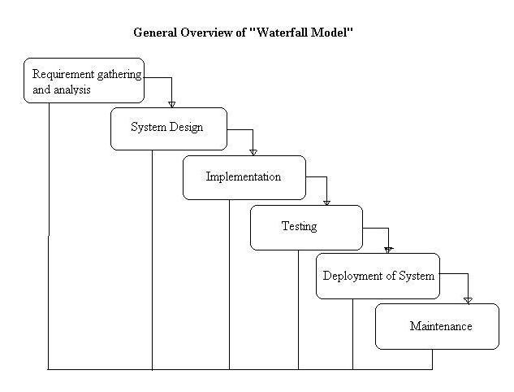

Figure 1: Iterative waterfall model

The iterative methodology is cyclical in nature, whereas the waterfall model is a linear SDLC model. Once the first requirement planning process is done, some of the other steps are repeated. The final product is improved and iterated upon as these cycles are finished and put into action.

Requirement gathering and analysis

This phase's goal is to accurately document the customer's needs and comprehend their precise nature. Together, the customer and the software developer document all of the software's functionalities, performance, and interface requirements. The researchers conduct an interview for teachers and principals. The gathered data will be the information about what is the current situation and make an appropriate approach.

System Design

The second phase is the most crucial to study after the first is finished and validated because it is used for system design. It aids in defining the software specifications needed for the client's design. Additionally, it aids in the design of the system's general architecture. In this step, the requirement specification is mainly examined and validated. The proponents decide on how it will build the application and how it will work.

Implementation

At this stage, the developer must focus on coding. The system design they obtained in the previous phase must be followed. The system design is translated into source code with finished modules of software. The software's creation, testing, and integration are all included. The proposed system will have a test if all the functions work accordingly. The developers will implement the design according to the requirements of the system.

Testing

Following the testing of each unit created during the implementation phase, the entire system is merged. The entire system is tested for errors and failures after integration. The product can now be tested. Any issues are meticulously found and reported by developers. Your project might need to go back to phase one for reevaluation if significant problems show up. The developers will make sure that there are no bugs in the system to make sure that users can use it easily.

Deployment of System

This stage involves deploying the software onto the client's server in order to evaluate its functionality. The program is made available to end users once it has been implemented. This step may also involve teaching actual users about the system's advantages. The users will start using the system. The proponents will integrate the programs and the proponents will make a demo to be more familiarized.

Maintenance

To guarantee smooth functioning after the deployment phase, the software must thereafter be supported and maintained. Maintenance covers debugging and new additional choices. This stage's main objective is to fix any flaws or difficulties that the client or consumers may have while using the product. The developer will fix the bugs that the user encountered.

Hardware/Software

Software:

* PHP – For creating dynamic content, database integration, and seamless web technology integration.
* HTML – For creating the structure and content web pages
* CSS – For styling and formatting web pages
* SQL – For managing and querying databases

Hardware:

* Operating System: Windows 10 – User-friendly interface, support for a variety of programming tools, and compatibility with other Microsoft services commonly used in software development.
* Processer: AMD Ryzen 3550H with Radeon Vega Mobile GFX 2.10 GHz – Good performance for coding and other computing tasks.
* Installed RAM: 4.00 GB – For more complex programming and development workloads.
* System type: 64-bit operating system, x64-based processor – For running resource-intensive applications such as programming and development tools.

# References

Britannica, T. Editors of Encyclopaedia (2022, August 31). technology. Encyclopedia Britannica. <https://www.britannica.com/technology/technology>

Computer basics: What is a computer? (no date) GCFGlobal.org. Available at: <https://edu.gcfglobal.org/en/computerbasics/what-is-a-computer/1/>

How has technology changed education? (no date) Purdue University Online. Available at: <https://online.purdue.edu/blog/education/how-has-technology-changed-education>

Max Roser, Hannah Ritchie and Esteban Ortiz-Ospina (2016) - "Internet". Published online at OurWorldInData.org. Retrieved from: '<https://ourworldindata.org/internet>' [Online Resource]

Bouchrika, I. (2022, October 4). 51 LMS statistics: 2021/2022 data, Trends &amp; Predictions. Research.com. Retrieved December 16, 2022, from <https://research.com/education/lms-statistics>

Abdull Mutalib, A.A., Md. Akim, A. & Jaafar, M.H. A systematic review of health sciences students’ online learning during the COVID-19 pandemic. BMC Med Educ 22, 524 (2022). <https://doi.org/10.1186/s12909-022-03579-1>

Meenu Joshi (2022). What is an enrollment system and why does it matter? Retrieved from <https://www.leadsquared.com/industries/education/what-is-an-enrollment-system/>

Brush, K. (2019) What is a learning management system (LMS) and what is it used for?, CIO. TechTarget. Available at: <https://www.techtarget.com/searchcio/definition/learning-management-system>

Panchal, A. (2019, November 19). How to design the App Notification Strategy to Increase User Engagement. Creating the Right App Push Notifications Strategy to Increase User Engagement. Retrieved December 6, 2022, from <https://www.mindinventory.com/blog/how-to-design-app-notification-strategy-to-increase-user-enga>

Hasan Tinmaz & Jin Hwa Lee (2020). An analysis of users’ preferences on learning management systems: a case on German versus Spanish students. Retrieved from [https://slejournal.springeropen.com/articles/10.1186/s40561-020-00141-8#Sec11](https://slejournal.springeropen.com/articles/10.1186/s40561-020-00141-8" \l "Sec11)

Darren Turnbull, Ritesh Chugh & Jo Luck (2020). Learning Management Systems, An Overview. Retrieved from <https://www.researchgate.net/publication/335463920_Learning_Management_Systems_An_Overview>

Lester Reid (2019). Learning Management Systems: The Game Changer for Traditional Teaching and Learning at Adult and Higher Education Institutions. Retrieved from <https://globaljournals.org/GJHSS_Volume19/1-Learning-Management-Systems.pdf>

Khawlah Ahmed & Mujo Mesonovich (2019). Learning Management System and Student Performance. Retrieved from <https://infonomics-society.org/wp-content/uploads/Learning-Management-Systems-and-Student-Performance.pdf>

Sittichai Thammasane & Wanwika Sattaworn (2019). The Development Of The Free Enrollment System, Undergraduate Of Suan Sunandha Rakabhat University. Retrieved from <http://www.ijbts-journal.com/images/main_1366796758/V19-07%20Wanwika%20Sattaworn.pdf>

Suwitchan Kaewsiwan & Chadarat Khwunnak (2022). The Development of Web-Based Application of Registration System. Retrieved from <https://ph02.tci-thaijo.org/index.php/mijet/article/view/245801/167006>

Jonathan S. Dela Cruz & Ana Sheryl Lynn S. Catura (2020). E-Readiness for Learning Management Systems of a Higher Education Institution. Retrieved from <http://apjeas.apjmr.com/wp-content/uploads/2020/09/APJEAS-2020.7.4.2.03.pdf>

John Oliver P. Brioso (2017). An E-classroom Management System Implementation: Contextualization, Perception, and Usability. Retrieved from <http://buscompress.com/uploads/3/4/9/8/34980536/riber_6-s1_sp_s17-011_229-249.pdf>

Dave E. Marcial & Alfie Q. Arcelo (2016). Perceptions and Prioritization of a Portable Learning Management System. Retrieved from <http://uruae.org/siteadmin/upload/UH0516021.pdf>

Bognot, E., Wy, J., Santos, O., Merciales, R., Padilla, A., & Jocson, C. (2021). Process Optimization: An impact to the Enrollment System of Aurora State College of Technology. Retrieved from <https://journals.grdpublications.com/index.php/ijprse/article/view/485>

Capanas, A., Sunga, R., Mata, M., & Perez, P. (2018). Usability of Pangasinan State University Enrolment System. Retrieved from <https://www.asianjournal.org/online/index.php/ajbts/article/view/382>

Valencerina, H., Castro, D., Zapatero, P., & Visperas, M. (2019). COMPUTERIZED ENROLLMENT SYSTEM OF SAN JACINTO CATHOLIC SCHOOL INC. Retrieved from <https://pdfcoffee.com/computerized-enrollment-systemdocx-pdf-free.html>

Appendices

Appendix A. Gantt Chart

Calendar of Activities

Data Gathering

The data gathering started in the first week of September. The developers started the preparations for the thesis proposal by conducting an interview and survey. The title of the thesis proposal is Online Enrollment with E-learning Management System. To further gather data about the manual process of enrollment and E-learning management system, the developers interviewed the registrar, accountant, teachers, and students. This helped the developers to gather more accurate data about the manual process.

Documentation

In the first week of October, the developers started writing chapter 1 and chapter 2. In the first week of October, Jeriko Ronnel S. Coz and Rhandyl A. Tapuroc started conducting the introduction and background of the problem. After that, Justine Adrian A. Sirios started conducting the overview and scope & limitation and Dhan Exequiel M. Cultura started conducting literature review. The thesis proposal was finalized in the first week of December and started a mock defense.

System Design

In the first week of March, the developers started developing a data flow diagram for admin, teachers, and students. Justine Adrian A. Sirios, Jeriko Ronnel S. Coz, and Dhan Exequiel M. Cultura develop the data flow diagram for teachers, students, and admin. In the second week of March, Rhandyl A. Tapuroc started developing wireframe for teachers, students, admin, and accountant.

|  |  |  |  |  |  |  |  |  |  |  |  |  |  |  |  |  |  |  |  |  |  |  |  |  |  |  |  |  |  |  |  |  |  |  |  |  |  |  |  |  |
| --- | --- | --- | --- | --- | --- | --- | --- | --- | --- | --- | --- | --- | --- | --- | --- | --- | --- | --- | --- | --- | --- | --- | --- | --- | --- | --- | --- | --- | --- | --- | --- | --- | --- | --- | --- | --- | --- | --- | --- | --- |
| MONTH | JUNE | | | | JULY | | | | AUGUST | | | | SEPTEMBER | | | | OCTOBER | | | | NOVEMBER | | | | DECEMBER | | | | JANUARY | | | | FEBRUARY | | | | MARCH | | | |
| ACTIVITY |
| Groupings |  |  |  |  |  |  |  |  |  |  |  |  |  |  |  |  |  |  |  |  |  |  |  |  |  |  |  |  |  |  |  |  |  |  |  |  |  |  |  |  |
| Title Selection |  |  |  |  |  |  |  |  |  |  |  |  |  |  |  |  |  |  |  |  |  |  |  |  |  |  |  |  |  |  |  |  |  |  |  |  |  |  |  |  |
| Data Gathering |  |  |  |  |  |  |  |  |  |  |  |  |  |  |  |  |  |  |  |  |  |  |  |  |  |  |  |  |  |  |  |  |  |  |  |  |  |  |  |  |
| Chapter 1: Introduction |  |  |  |  |  |  |  |  |  |  |  |  |  |  |  |  |  |  |  |  |  |  |  |  |  |  |  |  |  |  |  |  |  |  |  |  |  |  |  |  |
| Chapter 1: Background of the Problem |  |  |  |  |  |  |  |  |  |  |  |  |  |  |  |  |  |  |  |  |  |  |  |  |  |  |  |  |  |  |  |  |  |  |  |  |  |  |  |  |
| Chapter 1: Overview |  |  |  |  |  |  |  |  |  |  |  |  |  |  |  |  |  |  |  |  |  |  |  |  |  |  |  |  |  |  |  |  |  |  |  |  |  |  |  |  |
| Chapter 1: Scope & Limitation |  |  |  |  |  |  |  |  |  |  |  |  |  |  |  |  |  |  |  |  |  |  |  |  |  |  |  |  |  |  |  |  |  |  |  |  |  |  |  |  |
| Chapter 2: Literature Review |  |  |  |  |  |  |  |  |  |  |  |  |  |  |  |  |  |  |  |  |  |  |  |  |  |  |  |  |  |  |  |  |  |  |  |  |  |  |  |  |
| Chapter 2: Synthesis |  |  |  |  |  |  |  |  |  |  |  |  |  |  |  |  |  |  |  |  |  |  |  |  |  |  |  |  |  |  |  |  |  |  |  |  |  |  |  |  |
| Chapter 2: Methodology |  |  |  |  |  |  |  |  |  |  |  |  |  |  |  |  |  |  |  |  |  |  |  |  |  |  |  |  |  |  |  |  |  |  |  |  |  |  |  |  |
| Chapter 2: Hardware/Software |  |  |  |  |  |  |  |  |  |  |  |  |  |  |  |  |  |  |  |  |  |  |  |  |  |  |  |  |  |  |  |  |  |  |  |  |  |  |  |  |
| Chapter 2: Gantt Chart |  |  |  |  |  |  |  |  |  |  |  |  |  |  |  |  |  |  |  |  |  |  |  |  |  |  |  |  |  |  |  |  |  |  |  |  |  |  |  |  |
| Chapter 2: Budgetary Estimate |  |  |  |  |  |  |  |  |  |  |  |  |  |  |  |  |  |  |  |  |  |  |  |  |  |  |  |  |  |  |  |  |  |  |  |  |  |  |  |  |
| Chapter 2: Human Resources |  |  |  |  |  |  |  |  |  |  |  |  |  |  |  |  |  |  |  |  |  |  |  |  |  |  |  |  |  |  |  |  |  |  |  |  |  |  |  |  |
|  |  |  |  |  |  |  |  |  |  |  |  |  |  |  |  |  |  |  |  |  |  |  |  |  |  |  |  |  |  |  |  |  |  |  |  |  |  |  |  |  |
|  |  |  |  |  |  |  |  |  |  |  |  |  |  |  |  |  |  |  |  |  |  |  |  |  |  |  |  |  |  |  |  |  |  |  |  |  |  |  |  |  |
|  |  |  |  |  |  |  |  |  |  |  |  |  |  |  |  |  |  |  |  |  |  |  |  |  |  |  |  |  |  |  |  |  |  |  |  |  |  |  |  |  |
|  |  |  |  |  |  |  |  |  |  |  |  |  |  |  |  |  |  |  |  |  |  |  |  |  |  |  |  |  |  |  |  |  |  |  |  |  |  |  |  |  |
|  |  |  |  |  |  |  |  |  |  |  |  |  |  |  |  |  |  |  |  |  |  |  |  |  |  |  |  |  |  |  |  |  |  |  |  |  |  |  |  |  |

Legend:

|  |  |
| --- | --- |
| On-going | Complete |

Appendix B. Actual Thesis Expenses

THESIS EXPENSES

Thesis 0

|  |  |  |
| --- | --- | --- |
| Quantity | Specifics | Approximate cost |
| 4 | Transportation | Php 1,000 |
| 500 | Short Bond Paper | Php 250 |
| 3 | White Folder | Php 100 |
| 222 | Printing | Php 230 |
| Total: Php 1,380 | | |

Thesis 1

|  |  |  |
| --- | --- | --- |
| Quantity | Specifics | Approximate cost |
| 4 | Transportation | Php 1,000 |
| 1 | Hosting | Php 169 per month |
| 1 | Cloud Server | Php 50 per month |
| Total: Php 3,628 | | |

Prepared by:

Jeriko Ronnel S. Coz Justine Adrian A. Sirios

Dhan Exequiel M. Cultura Rhandly A. Tapuroc

Noted by:

Amabelle A. Tapuroc Grace Gwendolyn S. Coz

Annaliza M. Cultura Roger F. Sirios

Approved by:

Gerven Jay Regado Lexter A. Santos

Appendix c. Curriculum Vitae of Researchers

Curriculum Vitae of

JERIKO RONNEL S. COZ

Blk. 8, Lot 37, Baytown Homes, Angono, Rizal

Jerikoco@gmail.com

09461453209

EDUCATIONAL BACKGROUND

|  |  |  |
| --- | --- | --- |
| Level | Inclusive Dates | Name of school/ Institution |
| Tertiary | 2020 - present | STI College Ortigas-Cainta |
| TechVoc | 2016 - 2018 | APEC |
| High School | 2012 - 2016 | Angono Private High School |
| Elementary | 2012 - 2016 | JGES |

PROFESSIONAL OR VOLUNTEER EXPERIENCE

|  |  |  |
| --- | --- | --- |
| Inclusive Dates | Nature of Experience/  Job Title | Name and Address of Company or Organization |
| None |  |  |
|  |  |  |
|  |  |  |
|  |  |  |

Listed in reverse chronological order (most recent first).

AFFILIATIONS

|  |  |  |
| --- | --- | --- |
| Inclusive Dates | Name of Organization | Position |
| None |  |  |
|  |  |  |
|  |  |  |
|  |  |  |

Listed in reverse chronological order (most recent first).

SKILLS

|  |  |  |
| --- | --- | --- |
| SKILLS | Level of Competency | Date Acquired |
| Technical Writing | Intermediate | 2020 |
| Software Development | Intermediate | 2017 |
| Creativity | Intermediate | 2017 |

TRAININGS, SEMINARS OR WORKSHOP ATTENDED

|  |  |
| --- | --- |
| Inclusive Dates | Title of Training, Seminar or Workshop |
| None |  |
|  |  |
|  |  |
|  |  |

Listed in reverse chronological order (most recent first).

Curriculum Vitae of

DHAN EXEQUIEL M. CULTURA

Rm. 408, B3, East Summit Residence, San Isidro, Ortigas Ext., Cainta

Dhanmanaog@gmail.com

09473962626

EDUCATIONAL BACKGROUND

|  |  |  |
| --- | --- | --- |
| Level | Inclusive Dates | Name of school/ Institution |
| Tertiary | 2020 - present | STI College Ortigas-Cainta |
| TechVoc | 2018 - 2020 | College of St. John Paul II Art & Science |
| High School | 2012 - 2017 | St. Gabriel International School |
| Elementary | 2007 - 2012 | New Town Primary School  Gih Moh Primary School |

PROFESSIONAL OR VOLUNTEER EXPERIENCE

|  |  |  |
| --- | --- | --- |
| Inclusive Dates | Nature of Experience/  Job Title | Name and Address of Company or Organization |
| 2019 - 2020 | On the Job Trainee |  |
|  |  |  |
|  |  |  |
|  |  |  |

Listed in reverse chronological order (most recent first).

AFFILIATIONS

|  |  |  |
| --- | --- | --- |
| Inclusive Dates | Name of Organization | Position |
| None |  |  |
|  |  |  |
|  |  |  |
|  |  |  |

Listed in reverse chronological order (most recent first).

SKILLS

|  |  |  |
| --- | --- | --- |
| SKILLS | Level of Competency | Date Acquired |
| Software Development | Intermediate | 2020 |
| Communication | Advanced | 2007 |
| Computer Literate | Intermediate | 2009 |
| Attention to Detail | Intermediate | 2017 |

TRAININGS, SEMINARS OR WORKSHOP ATTENDED

|  |  |
| --- | --- |
| Inclusive Dates | Title of Training, Seminar or Workshop |
| None |  |
|  |  |
|  |  |
|  |  |

Listed in reverse chronological order (most recent first).

Curriculum Vitae of

JUSTINE ADRIAN A. SIRIOS

49 Pechay St. Napico Manggaghan Pasig City

Justinesirios@gmail.com

09686033433

EDUCATIONAL BACKGROUND

|  |  |  |
| --- | --- | --- |
| Level | Inclusive Dates | Name of school/ Institution |
| Tertiary | 2020 - present | STI College Ortigas-Cainta |
| TechVoc | 2016 - 2018 | Arellano University Pasig |
| High School | 2012 - 2016 | Sta. Lucia High School |
| Elementary | 2006 - 2012 | Napico Elementary School |

PROFESSIONAL OR VOLUNTEER EXPERIENCE

|  |  |  |
| --- | --- | --- |
| Inclusive Dates | Nature of Experience/  Job Title | Name and Address of Company or Organization |
| None |  |  |
|  |  |  |
|  |  |  |
|  |  |  |

Listed in reverse chronological order (most recent first).

AFFILIATIONS

|  |  |  |
| --- | --- | --- |
| Inclusive Dates | Name of Organization | Position |
| None |  |  |
|  |  |  |
|  |  |  |
|  |  |  |

Listed in reverse chronological order (most recent first).

SKILLS

|  |  |  |
| --- | --- | --- |
| SKILLS | Level of Competency | Date Acquired |
| Software Development | Intermediate | 2020 |
| Technical Writing | Intermediate | 2016 |
| Attention to Detail | Intermediate | 2016 |
| Creativity | Intermediate | 2012 |
| Communication | Intermediate | 2012 |

TRAININGS, SEMINARS OR WORKSHOP ATTENDED

|  |  |
| --- | --- |
| Inclusive Dates | Title of Training, Seminar or Workshop |
| None |  |
|  |  |
|  |  |
|  |  |

Listed in reverse chronological order (most recent first).

Curriculum Vitae of

RHANDYL A. TAPUROC

Mapalad St. Arenda, Brgy. Sta. Ana, Taytay, Rizal

Rattapuroc@gmail.com

09157845474

EDUCATIONAL BACKGROUND

|  |  |  |
| --- | --- | --- |
| Level | Inclusive Dates | Name of school/ Institution |
| Tertiary | 2019 - present | STI College Ortigas-Cainta |
| TechVoc | 2015 - 2017 | AMA Computer Learning Center (ACLC) |
| High School | 2011 - 2015 | Star of Hope Christian School |
| Elementary | 2005 - 2011 | Ilugin Elementatry School |

PROFESSIONAL OR VOLUNTEER EXPERIENCE

|  |  |  |
| --- | --- | --- |
| Inclusive Dates | Nature of Experience/  Job Title | Name and Address of Company or Organization |
| 2021 - 2022 | Technical Head | Arenda Pragmatic Alliance of Youth Organization (PAYO) |
| 2016 | Volunteer | Brgy. Dolores |
|  |  |  |
|  |  |  |

Listed in reverse chronological order (most recent first).

AFFILIATIONS

|  |  |  |
| --- | --- | --- |
| Inclusive Dates | Name of Organization | Position |
| None |  |  |
|  |  |  |
|  |  |  |
|  |  |  |

Listed in reverse chronological order (most recent first).

SKILLS

|  |  |  |
| --- | --- | --- |
| SKILLS | Level of Competency | Date Acquired |
| Software Development | Intermediate | 2017 |
| Technical Writing | Intermediate | 2016 |
| Attention to Detail | Advanced | 2015 |
| Creativity | Advanced | 2015 |
| Communication | Intermediate | 2015 |

TRAININGS, SEMINARS OR WORKSHOP ATTENDED

|  |  |
| --- | --- |
| Inclusive Dates | Title of Training, Seminar or Workshop |
| None |  |
|  |  |
|  |  |
|  |  |

Listed in reverse chronological order (most recent first).

appendix d: project proposal letter

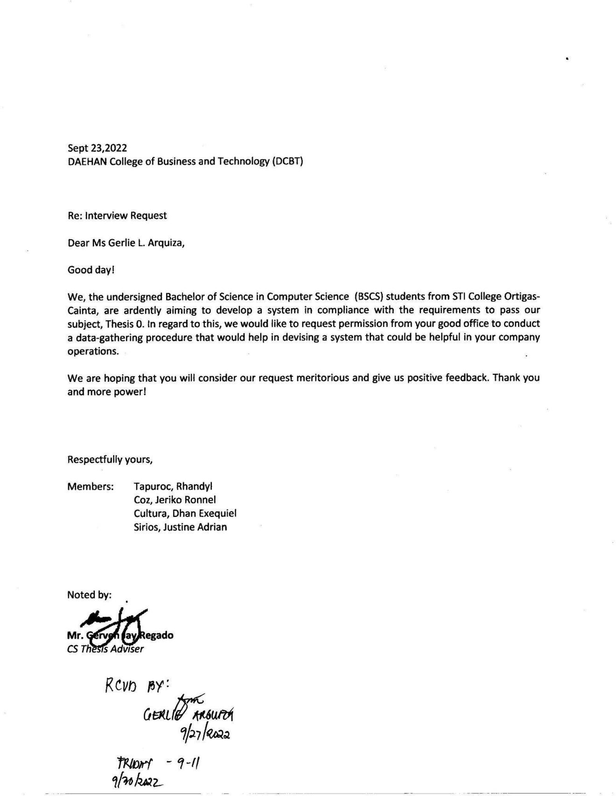

appendix e: research design

The study that the researchers used is a combination of qualitative and quantitative data collection for principal, teachers, and students to understand the problems and issues the school faces. The researchers collect qualitative data by interviewing both principal and teachers in person about the issues that they encountered and the features they would want to see in a learning management system. Qualitative data is defined as non-numerical data, such as text, video, photographs or audio recordings. This type of data can be collected using diary accounts or in-depth interviews, and analyzed using grounded theory or thematic analysis. (McLeod 2019) Using this research approach will help researchers to gain reliable and informative information. The researchers uses quantitative data through the assessment of the answers in a 32-item survey questionnaire for students and 28-item survey questionnaire for teachers which pertains to the experience of teachers and students using several platforms for learning. Quantitative data is information about quantities, and therefore numbers, and qualitative data is descriptive, and regards phenomena which can be observed but not measured, such as language. (McLeod 2019)

appendix f: location of the school

School Location:

Road 20, Sitio Siwang, San Juan, Taytay, Rizal

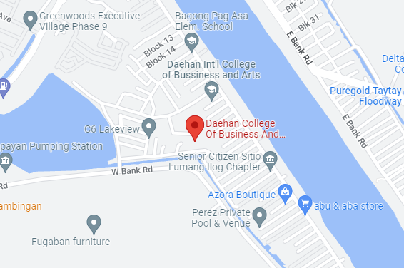

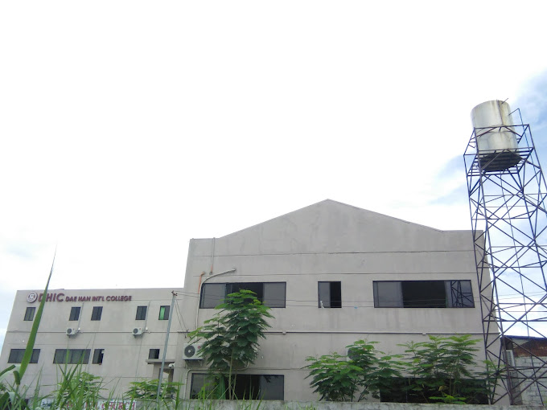

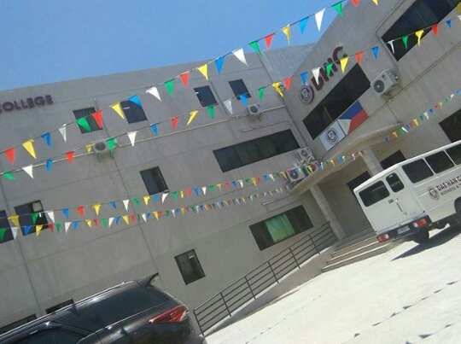

appendix g: company letter

December 9, 2022

Daehan College of Business and Technology

Road 20, Sitio Siwang, San Juan, Taytay, Rizal

Dear Ma’am/Sir,

In line with STI College Ortigas-Cainta’s mission of producing high standard and quality graduates, we are deploying our students to conduct an in-depth study on current system of different establishment for Computer Science as partial fulfilment with requirements for Bachelor of Science in Computer Science.

It is in this regard that we are requesting your office to accommodate the following student to conduct a study of your current system.

Coz, Jeriko Ronnel S.

Cultura, Dhan Exequiel M.

Sirios, Justine Adrian A.

Tapuroc, Rhandyl A.

We highly appreciate all the help that you can extend to our students. Rest assured that all information gathered would be kept confidential and will be intended for use only in development of their project proposal entitled, “E-Learning Management System with SMS notification for Student grade and school announcement for Daehan College of Business and Technology”.

The final output in the form of software will be forwarded to you as soon as development is through, and the system is ready for implementation.

Thank you very much. GOD Bless.

Respectfully yours, Noted by:

_______________________ __________________

Lexter A. Santos Prof. Gerven Jay Regado

Thesis Coordinator Thesis Adviser

appendix h: delimitatins of the study

The researchers limited the population of this research to principal, teachers, and students of Daehan College of Business and Technology in order for the study to be more precise with its recommendations and for the benefits of both the school and the teachers. The researchers came to the conclusion that the plan for creating interview questions and survey questionnaire answered by the principal, teachers, and students.

appendix i: population of the study

The target population of the researchers are the principal, teachers, and students of Daehan College of Business and Technology. The researchers ask several questions to the principal and teachers in person that are currently using learning platforms.

appendix j: sample of population

The researchers will provide interview questions to the 2 teachers of SHS and 1 teacher of college. By doing so it provides us the important information of how they adjust themselves in an online learning environment and the difficulties that they have encountered.

appendix k: sampling technique

Purposive sampling and Random sampling is the sampling technique used by the researchers. By doing this technique, the researchers will be able to hear it directly from the interviewee providing us the best information and giving out surveys to the teachers and students resulting in a more accurate data gathered.

appendix l: instrument for data collection

The researchers have provided 20 interview questions, 30-item survey questionnaires for students, and 28-item survey questionnaires for the teachers as the instrument for data collection. The interview questions mainly asked the principal, 222 students and 3 teachers of their experience and opinion upon using several learning platforms to meet students' activities and school related works. The survey questionnaires mainly asked the teachers and students of their opinion upon using several platforms such as Messenger, Google Classroom, Google Drive etc. It revolves around topics such as user-experience, accessibility, announcements and notifications, grades, tasks, deadlines, modules, and concerns.

appendix m: method of data collection

The method of data collection that the researchers used is a 20-item interview question for teachers and principal, 30-item survey questionnaires for students, and 28-item survey questionnaires for the teachers of Daehan College of Business and Technology.

appendix n: sample interview questions

1. What apps are you currently using in online learning?
2. Are the apps that you are using different from the other teachers?
3. Are the students able to cope with the apps that you are currently using?
4. Which part are the students having difficulties and why?
5. What is an appropriate suggestion for them in order to lessen the difficulties that they are experiencing?
6. What are the problems they encountered when using multiple apps?
7. What is the manual process for students when it comes to their grades?
8. What are the problems they encountered during the manual process?
9. Are they willing to transfer from excel to database?
10. How do teachers track the students’ progress?
11. What are the problems they have encountered?
12. Are you willing to track the students’ progress using a system?
13. What is the manual process for the module?
14. What are the problems that you have encountered?
15. Are you willing to use paperless for the module?
16. What is the manual process for the tasks?
17. What are the problems that you have encountered?
18. Are you willing to use paperless for the tasks?

appendix o: survey questionnaire

Students:

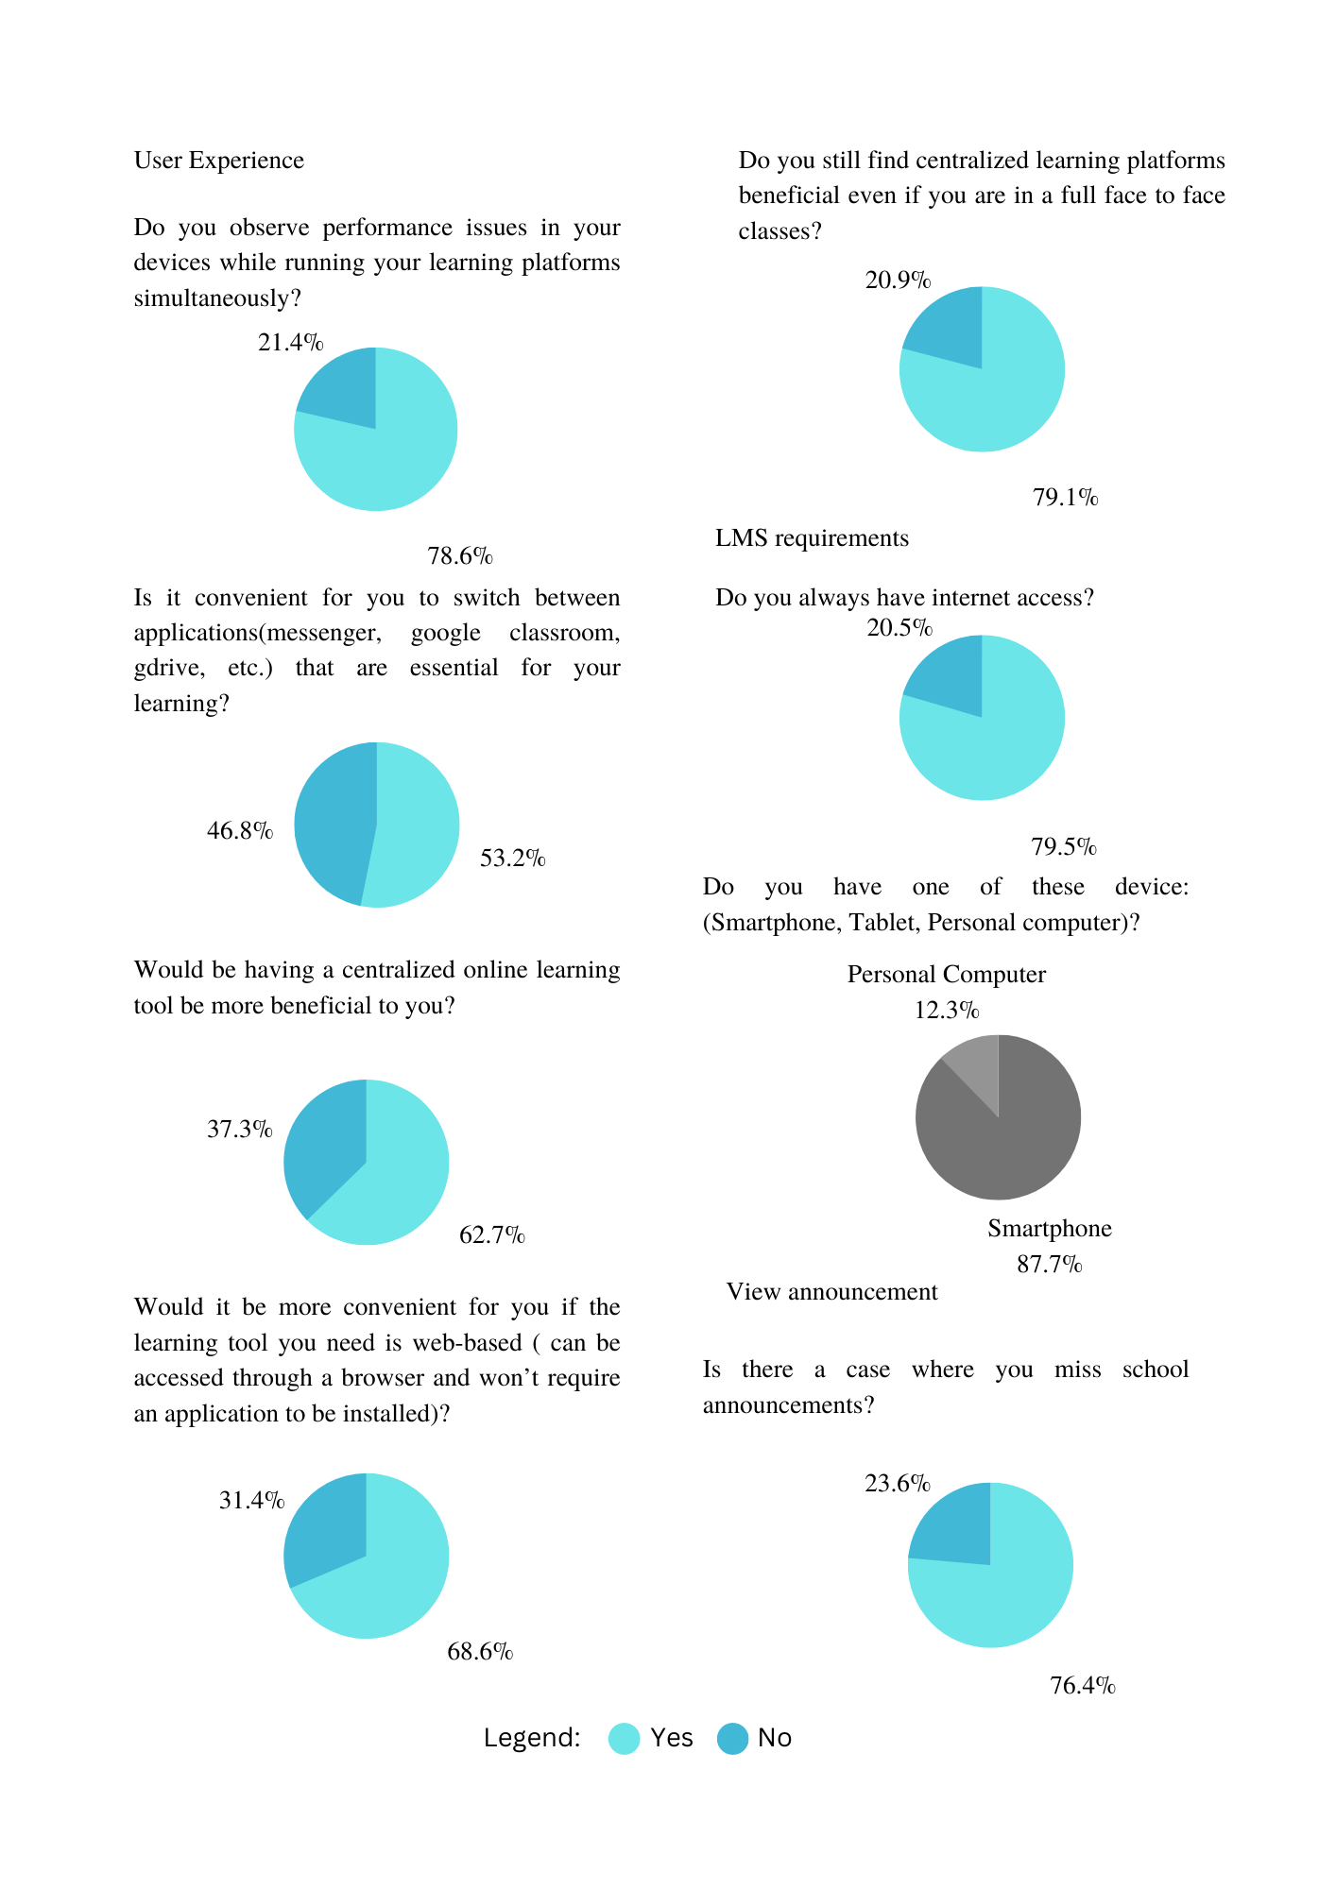

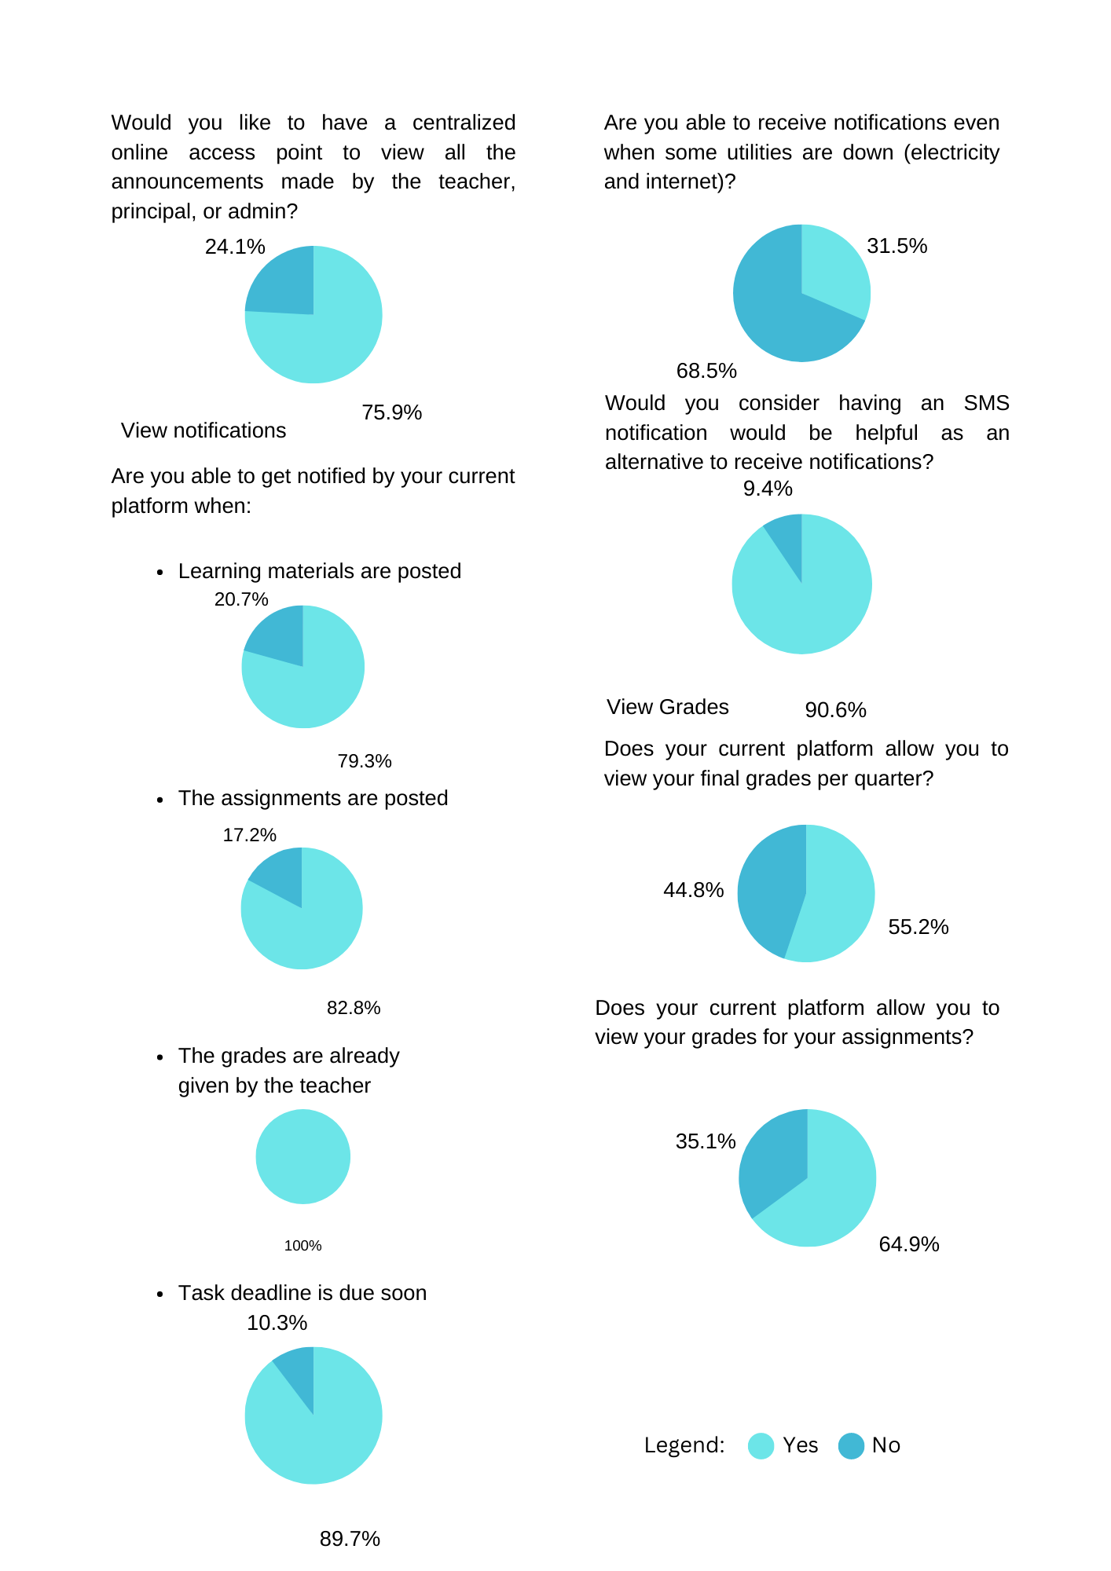

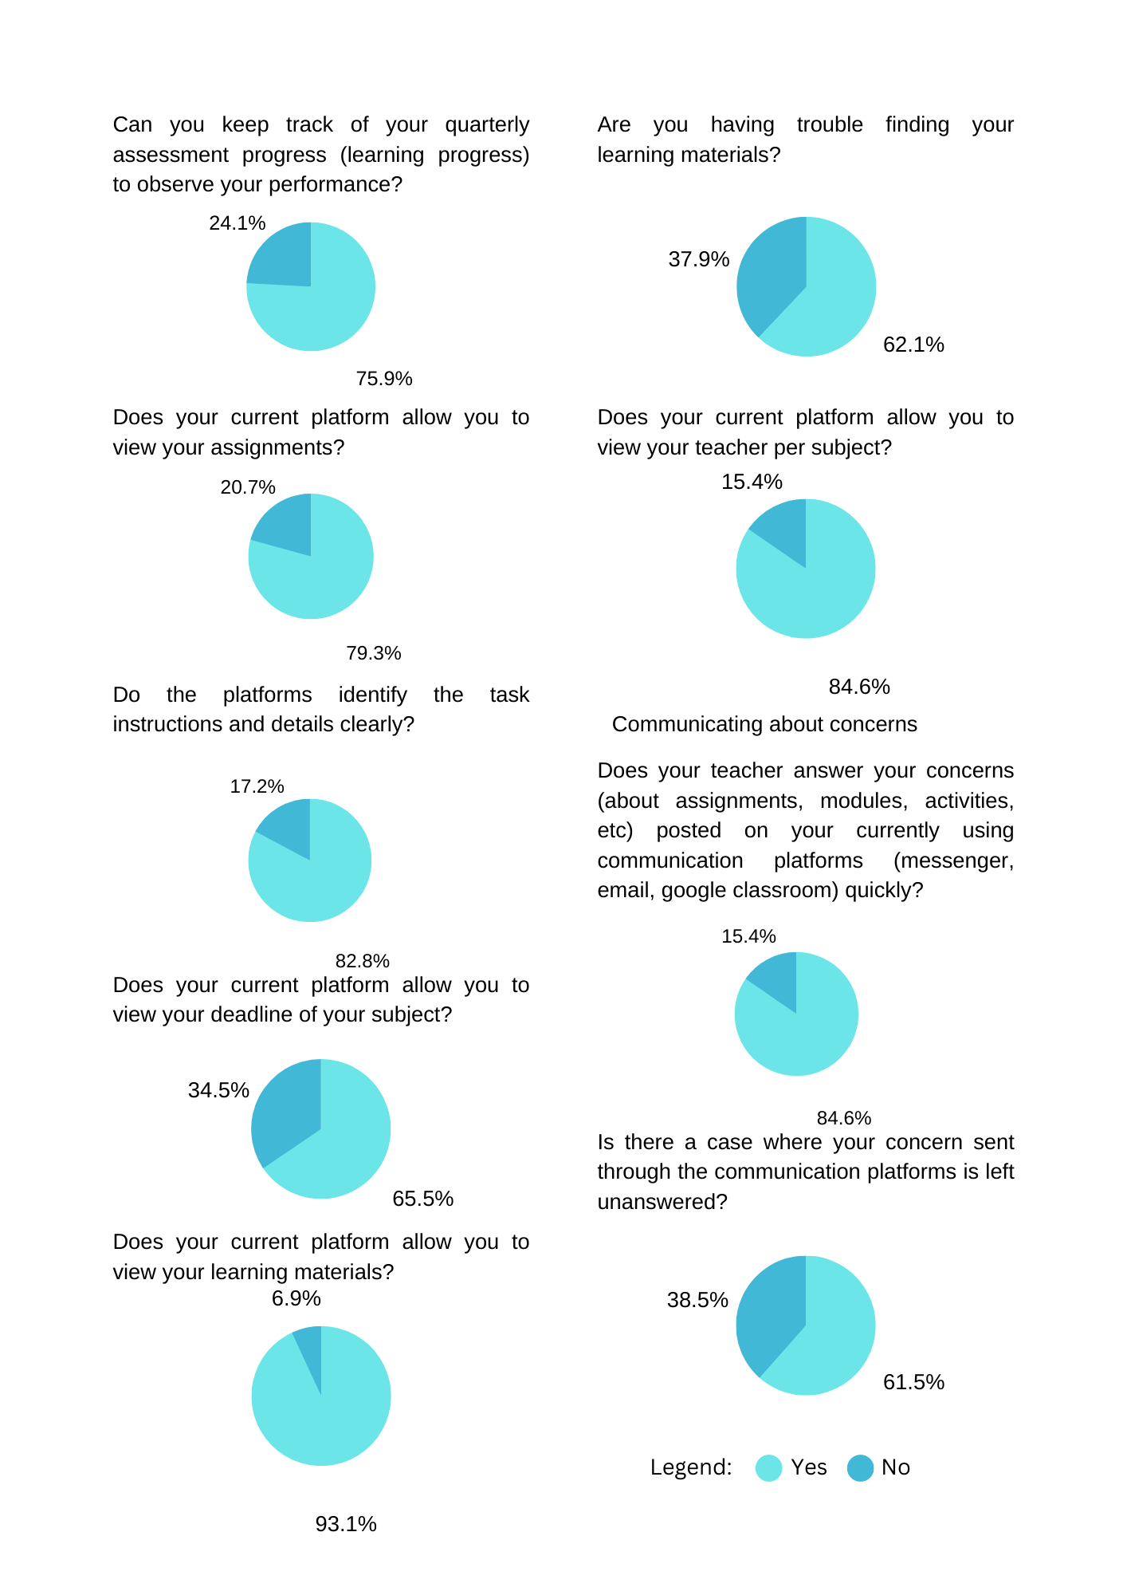

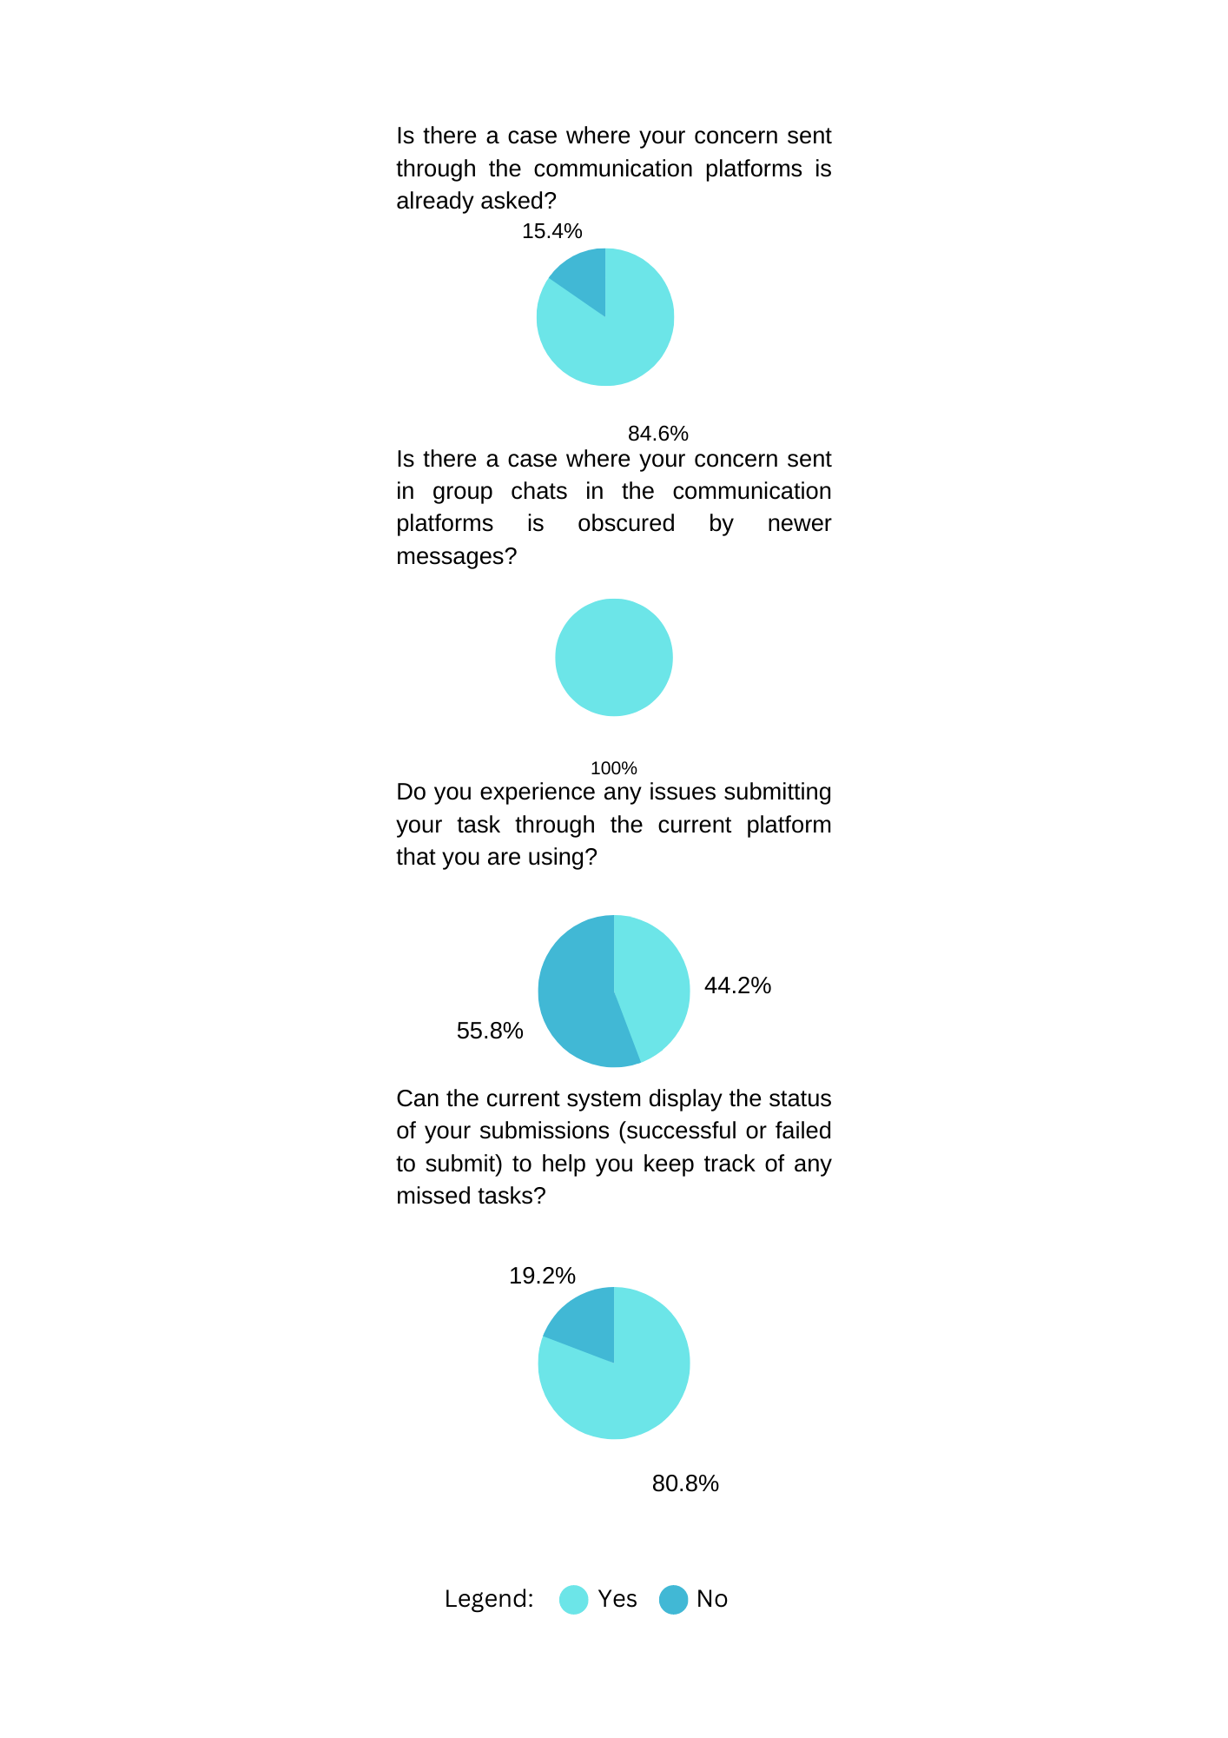

Teachers:

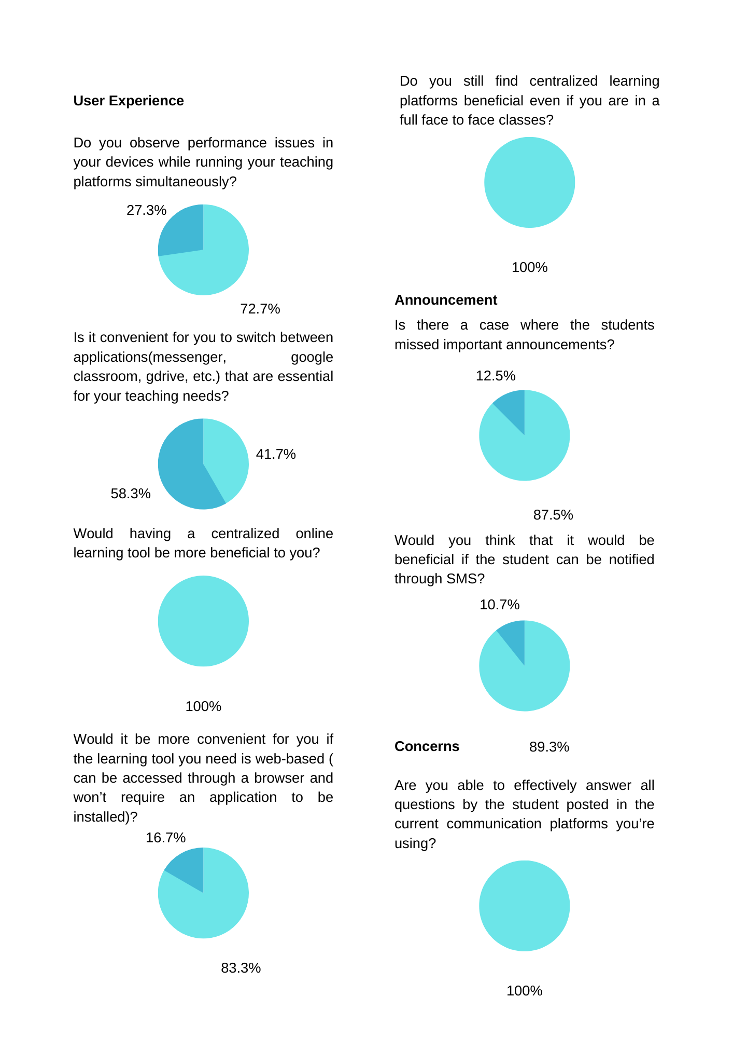

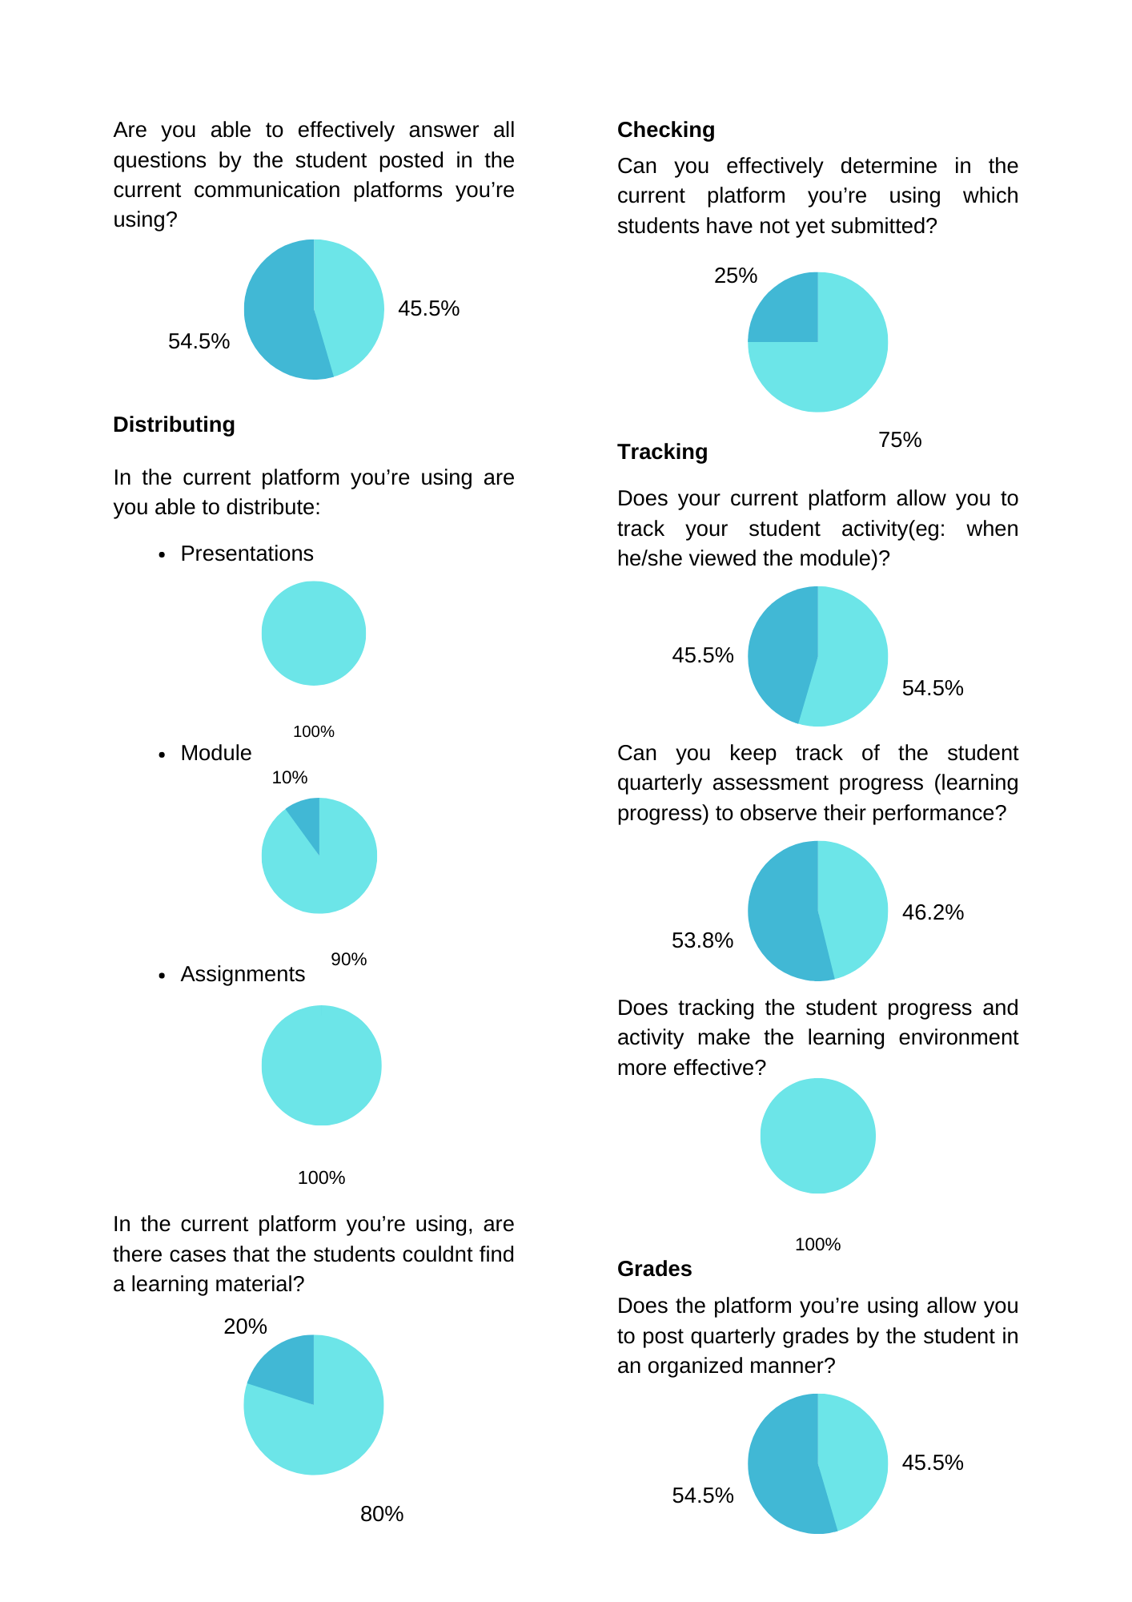

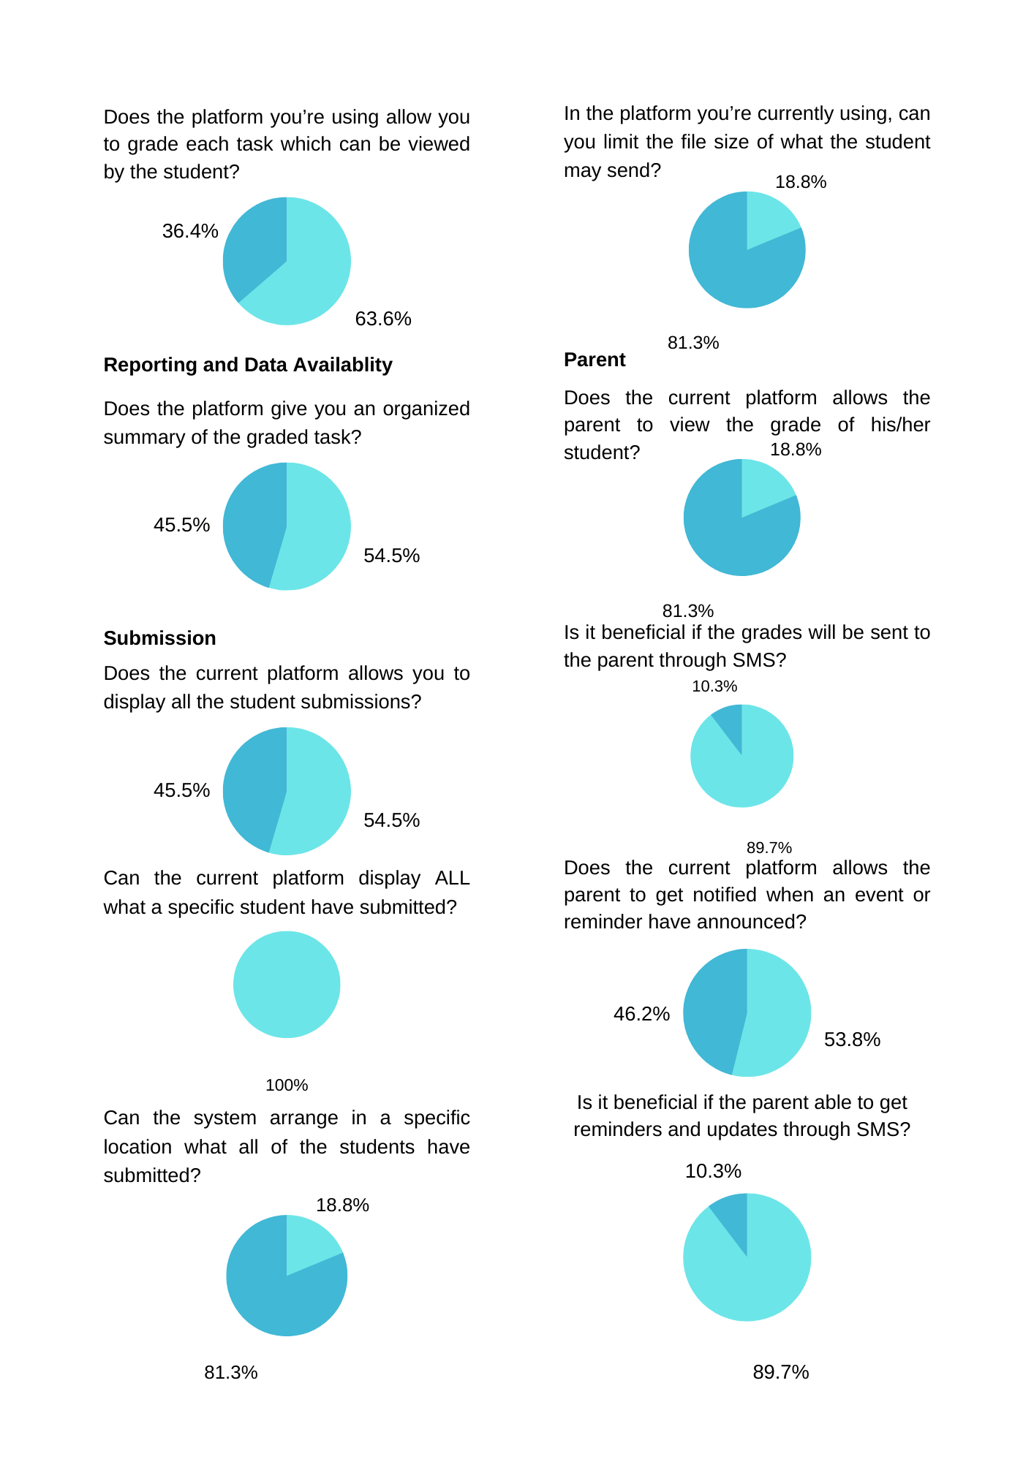

appendix p: transcript

September 30, 2022

(Principal)

00:00: Cultura: good morning po, interview po for elms.

00:03: Gerlie Arquiza: go ahead

00:11: Cultura: Saan po kayo nakakakuha ng module?, sa STI po meron pong taga gawa ng modules per subject.

00:21: Gerlie Arquiza: samin is kung anong subject mo ikaw gagawa ng sarili mong module.

00:29: Cultura: Sa database po is pareho yung modules, kunwari po sa isang subject may isang arg ganun po.  pag iba iba po hindi po namin sya ma apply sa database kasi po mas maganda po sana if pare pareho po. pwede po bang i-apply yun?

00:51: Cultura: so same module lang po sila?

00:53: Gerlie Arquiza: same module. may naka assign na oh ikaw ang gagawa pero yung module pareho pa rin yung pinang gagalingan.

 01:01: Cultura: kunwari po if meron pong mag upload ng module sa database, so yun po yung gagamitin nilang reference ng pag gagawa ng sarili nilang module?

01:12: Gerlie Arquiza: oo, ganun

01:14 Cultura: sa elms po marami rin naman pong coverage depende rin po sa kung anong kailangan niyo so isa rin po dun yung modules pwede pong i take home siya naka upload na po kung ano po yung presentation nandun na rin po tsaka po pwede pong basahin pwede na rin pong tingnan po ng students then yung dun sa task po assignments pwede na rin po don.

01:41 : Gerlie Arquiza: oo, ganyan yung gusto namin.

1:45: Cultura: yun lang po, thank you po

October 25, 2022

(Teachers)

00:00: Rhandyl- ang proposal po namin is lms. Gusto niyo po ba na ganun?

00:08: Claire Vargas: Oo, mas maganda may ganun

00:12: Claire Vargas:  Pano naman yung about sa safety measure niyo? paano kung may mga students na ganyan din, magaling sa mga computers?

00:20 :Rhandyl: Meron po kaming safety measures, may security po ang elms .

00:28: Rhandyl: about naman po sa email ng student is mag gegenerate po ang elms ng sariling email po and password for elms.

00:36: Rhandyl: sa module naman po, san po nanggagaling yung reference para po sa pag gawa ng module.

00:41: Claire Vargas: Subject lang yung binigay samin tapos kami na bahala gumawa ng module. Yung module is minomodify namin dipende sa level of understanding ng student. So nag piprint sila ng hard copy para pag sa review.

00:59: Rhandyl: So pag isang prof po na may same subject sa dalawang section but different modules?

01:06: Claire Vargas: Hindi, same assignments, quiz, activity sila kasi same subject naman sila.

01:12: Claire Vargas: Clarify ko lang about sa email, elms na mag gegenerate ng email for students and teachers?

01:19: Rhandyl: Yes po, si lms na po bahala dun, sa admin naman po is kami po ang gagawa.

01:27: Claire Vargas: ah, okay

1:29: Rhandyl: Sa structure po ng subject san po manggagaling yun?

1:33: Claire Vargas: naka align siya sa kung anong strand, yung designated nun is to the principal.

Rhandyl: Samin po kasi is yung pag clinick mo po ang subject sa elms is nakalagay na po dun yung title po or name po ng topic for prelim.

Claire Vargas: Meron nun sa kanilang hard copy nila, upon enrollment nakalagay na dun yung mga subject nila per sem from the principal.

Rhandyl: So about po sa subject, binibigay po sa inyo yun tapos kayo na po bahala sa module, saan po kayo kumukuha ng reference para po makagawa ng module? saan po kayo bumabase?

Claire Vargas: Bumabase kami sa syllabus ng DepEd

Rhandyl: yun lang po, thank you po

December 5, 2022

(Teachers)

Students: Good morning po, Interview po

Christine Kim: okay, go ahead

Coz:  Ano ano po ang  ginagamit nyong applications?

Christine Kim: Ang ginagamit naming apps is yung Google drive, Google Classroom at Messenger. na yung ibang students nahihirapan sa apps dahil hindi familiar.

Coz: okay naman po ba yung modular?

Christine Kim: Yung sa modular okay para sa online pero yung face to face hindi kasi pumupunta pa sila dito sas school para makapag print

Coz: Bakit gusto po nila ng modular?

Christine Kim: Kasi may mga trabaho at ang iba lumipat ng ibang lugar.

Coz: Kelan po kayo nag start na gumamit ng apps?

Christine Kim: Nung pandemic para makapag klase

Coz: Bakit google classroom?

Christine Kim: Kasi mabilis gamitin

Coz: Maituturing po bang problema ng school to

Christine Kim: Opo kasi matagal yung pag load para sa students and kailangan pang idownload yung mga tasks ng mga bata at nakaka consume sa time and memory

Coz: Pag naimplement po ba yung system magagamit niyo po pa rin ba sa ftf?

Christine Kim: Oo magagamit parin siya kasi sa lms niyo diba yung pag view ng mga learning tools for reviewing, activities at assignments. tapos andun na rin yung pag grade ng tasks diba.

Coz: Sa module po kunwari po dalawang teachers, isang modules lang po yung gagamitin pag same subjects? Isang module lang gawin tapos isedend nalang sa isa?

Christine Kim: Opo

Coz: Okay lang po ba sa inyo na sa lms pag same subj lalabas na rin po sa isa?

Christine Kim: Oo mas okay yun

Coz: Yung pag process po pag bigay ng module pano po yun?

Christine Kim: Every two weeks kami nag bibigay ng module. Sinali namin sila sa isang gc, lahat ng strand is nasa isang gc  na same subject syempre, para sa pagbibigay ng module isahan na lang. Lahat lang ng same subj so may mga handle akong ibang subj so may ibang gc din yon

Coz: Mahirap po ba siya para sa inyo?

Christine Kim: Oo sobra kasi mag may mga tanong na natatakpan o kaya naman paulit ulit

Coz: Sa students po natatrack niyo po ba yung progress nila?

Christine Kim: Hindi namin natatrack kasi walang features yung app na ginagamit namin

December 9, 2022

Students: Good morning po, interview po

Teresa M. Oro: Go ahead

Sirios: about po modules, saang application niyo po binibigay mga modules?

Teresa M. Oro: Binibigay namin ang modules sa google classroom at messenger.

Sirios: about po sa grades, nakikita po ba ni parents yung grade?

Teresa M. Oro: oo

Sirios: ano po process niyo?

Teresa M. Oro: may binigay kaming index card sa bata tapos papapirmahan sa magulang at ibabalik ng mga bata samin.

Sirios: clarify lang po, pinapapirma ng bata po yung index card sa magulang tapos binabalik po sa inyo for proof po?

Teresa M. Oro: opo

Students: Thank you po

appendix q: teachers, shs and college student population

|  |  |
| --- | --- |
| College Courses | Students |
| Bachelor of Physical Education(BPE) | 19 |
| Bachelor of Entrepreneurship(Entrep.) | 14 |
| Bachelor of Technical Teacher Education(BTTE) | 5 |
| Bachelor of Arts and English | 5 |
| Total | 43 |

|  |  |
| --- | --- |
| SHS Strands | Students |
| HUMSS | 121 |
| ABM | 74 |
| GAS | 52 |
| HE | 67 |
| ICT | 79 |
| EIM | 12 |
| Total | 405 |

|  |  |
| --- | --- |
|  | Students |
| College | 43 |
| SHS | 405 |
| Total | 448 |

|  |  |
| --- | --- |
| College Teachers |  |
| Full-Time | 0 |
| Part-Time | 16 |
| Total | 16 |

|  |  |
| --- | --- |
| SHS Teachers |  |
| Full-Time | 7 |
| Part-Time | 6 |
| Total | 13 |
| SHS/College Teachers |  |
| Full-Time | 7 |
| Part-Time | 22 |
| Total | 29 |

appendix r: organizational chart

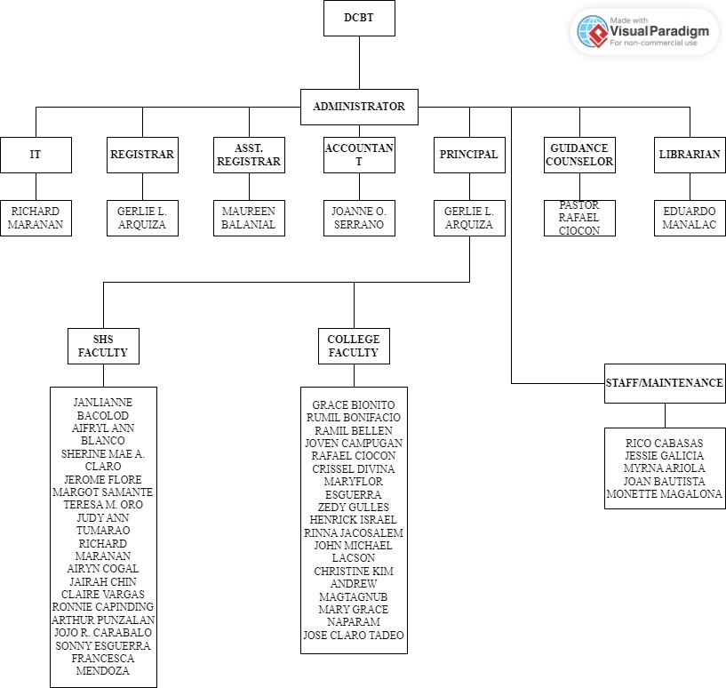

Figure 2: DCBT Organizational Chart